**CHAPTER ONE**

INTRODUCTION

Events are occurrences happening at a determined time and place, it is also something significant or notable that usually happens as a planned occasion or activity. Event planning is, therefore, the process of managing an occurrence or happening such as a party, ceremony, team building activity, or convention. Event planning entails budgeting, setting up timelines, selecting and booking the event sites, acquiring permits, planning for food, coordinating transport, coming up with a theme, it consists of coordinating every detail of meetings and convention, from the speakers and venue to organization of printed materials and audio-visual equipment among others. It starts with determining the objective that the sponsoring organization wants to achieve. Organizers choose a public address, entertainment, content and arrange the program to present the organization's information in the most efficient way. The organizers are responsible for selecting, prospective attendees and how to get them to the meeting.

Therefore, Event Planning is an uphill and demanding task. Planners must multi-task, face numerous deadlines and orchestrate the activities of many diverse groups of people. Organizers may need to travel extensively to attend meetings and to visit prospective sites and meet suppliers.

* 1. **Scope of the Project**

This project covers the design and implementation of an online Event management system which will be easy and efficient to use.

* 1. **Objectives of the Project**
* Online reservation of services (event booking): Customers will be able to use the system to make booking and schedule events online.
* Customer complaints and feedback: The system will allow customers to send complaints and feedback.
* Online Payments methods: The system will allow customers pay through transfer method to avoid stressing them unnecessarily.

**1.3 Significance of the system**

The system will be beneficial in the following ways:

* The company will be able to send notification to clients regarding status of their events through emails.
* Sends emails to customers to confirm if they cancelled events

The clients will benefit from the system by;

* Having easyaccess to various event packages.
* Using online payment platform which is fast and secure
* Getting feedback from event managers.
* Time management. The clients time lost during the travelling to and from the company to make reservation has been eliminated.

**1.4. Justification**

This project is being carried out to ensure that event organizers that have the needed budget do not get stressed out by unnecessary hustling and inquiries as they can easily make arrangements for the event from the comfort of their homes at any time of the day and allow the event planners and managers handle all the work for them while they get feedback on how far the planners have gone with the organization.

**1.5.Report organization**

CHAPTER ONE

* 1. Scope and limitation
  2. Objective of the project
  3. Significance
  4. Justification
  5. Report organization

CHAPTER TWO

Literature review

CHAPTER THREE

3.1 Methodology

3.2 Equipment and tools used in website development

3.3 The system use case diagrams and flowchart

3.4 Challenges and constraints

CHAPTER FOUR

4.1 Implementation, testing and result

4.2 BEME

4.3 Observation

4.4 Discussion

CHAPTER FIVE

Summary

Conclusion

Recommendations

References

Appendix

Fig.1.1 Block diagram showing report organization.

**CHAPTER TWO**

**2.1 Literature Review**

The event industry has played a every important role in our society, as people have come up with a lot of occasions for organizing events such as educational seminar, birthdays, company parties etc. Based on facts events are also a part of everyone’s social life because many get to meet, talk and get acquainted with different people from different walks of life. Getting to the point where an event is well organized and successful it requires a thorough and detailed planning process. Event planners and managers need to collaborate with many other vendors, caterers, decorators e.t.c in order to come up with the most viable plan for events. In order to make events successful and well organized, all parts of the plan for the event must be in harmony and accordance in execution with one another. And risk management has a great importance during the entire planning process, so risk management should never be underestimated. Evaluation process after the events helps event planners and managers see which aspects should be improved and needs firmer development.

The Event Manager studies the requirements of the event carefully and using the event management system finds the estimated cost and informs the customer about it. The customer may check whether the cost suits the financial provisions of the event. The company can also offer some readymade packages to choose from.

If the customer agrees, the event is booked and the advance deposit is taken by the company. According to the requirements of the event, different bookings are made. A strategic schedule is prepared for smooth conduct of the event. The Event Management System helps the manager in different tasks of planning, scheduling and

conducting the event. This system provides instant access to event-related information.

According to Anton Shone and Bryn Parry, “the author of Successful Event Management”, an event is “That phenomenon arising from those non-routine occasions which have leisure, cultural, personal or organizational objectives set apart from the normal activity of daily life, whose purpose is to enlighten, celebrate, entertain or challenge the experience of a group of people.”

Andersson and Wesslau stated that when businesses use events, they get the possibility to have their own-right to the consumer during the duration of the event. So that if a company manages to get the consumer to attend its event, the distortion or irregularities from the competitors will be minimized during the duration of the event. Also, events contain tangible elements, such as food, beverages and other products sold or given away, but are essentially a service in that they consist of intangible experiences of finite duration within a temporary, managed atmosphere. No matter the size and contents, events always have a way of surprising people, even though every part of the event are monitored and planned, the event will end up giving a person a physical experience that is entirely new and different from the previous ones.

Der Wagen once stated that “Event industry is service-oriented, which means that people have a tendency to enjoy the time of their lives. Customers are in need of making it possible, and afterwards, they would like to share their good moments with some other people. In order to deliver the best performances at events, there should be a well-adjusted balance between task management and people management. That being said, event managers should clarify responsibilities for different aspects of the events and be prepared for the worst scenario “.

Shone & Parry pointed out that planning an event teaches an organization how to utilize all of their resources as well as how to formulate best strategies to meet up with the current needs. From that perspective, the organization has good knowledge of how to boost up their own business. Which is why before planning an event, event managers should pay attention to developing purpose of events, developing objectives of events, preparing an event proposal and planning budget for the event. According to Watt in Event Management Handbook, Sapienza University of Rome, objectives should be:

* Specific: The event should be specific, not abstract or general. The purpose should be well-clarified to ensure that steps of planning are correct and appropriate.
* Measurable: The event should be measurable in terms of statistics. How many will attend? Or what quantity or quality is required?
* Attainable: Not only is the event measurable but it can be attainable by all the involved parties
* Time-bound: Time-bound concerns the time-management, timeframe and schedule.

Emmers and Wolff stated that event management entails the application of management in the creation and development of large-scale events. Lastly, Martin-Flatin, Jakobson and Lewis pointed out that the process of coordinating and planning events is usually regarded to as event planning and it includes a variety of things discussed above.

In the “Event Management System” for an “Event Management

Company”, a customer contacts the company for event management. He provides the details of the event and its requirements. He explains its aims, when and where the event will take place, how long it will last, its format expected number of delegates/guests, equipment and furniture required, whether any delegate pack or promotional material is to be distributed, and other facilities required. The Event Manager studies the requirements of the event carefully and using the event management system finds the estimated cost and informs the customer about it. The customer may check whether the cost suits the financial provisions of the event. The company can also offer some readymade packages to choose from. If the customer agrees, the event is booked and the advance deposit is taken by the company. According to the requirements of the event, different bookings are made. A strategic schedule is prepared for smooth conduct of the event. The Event Management System helps the manager in different tasks of planning, scheduling and

conducting the event. This system provides instant access to event-related information. Thus, resources are efficiently and economically utilized. Once the event is conducted successfully, the bills are generated by the system. The system is extensible. New functionalities can be added to the system, whenever it is needed due to changing requirements.

In order to develop an efficient system with good speed JavaScript, HTML, CSS and PHP, was used as development tools.

**2.2** **Static and Dynamic Websites**

**Difference Between Static and Dynamic Web Pages?**

1. Easier design updates

Dynamic websites offer easier design updates since the do not need to make changes in every page to simply change a piece of information on a page. In dynamic sites, each element of the page is different therefore, it is a lot easier to modify a particular element on different pages, all at once.

1. Loading speed

The loading and browsing of static sites are faster than dynamic websites because dynamic websites send requests to the server to display the content of a particular webpage which approximately takes 90% of the total loading time. However, static websites have nothing to do with server and therefore, directly load on the client’s browser without communicating with the server.

1. These sites are created using HTML and CSS while dynamic sites are built using various different programming languages such as JSP, ASP, Perl, Python and PHP. Today, a majority of webmasters are making use of content management systems to create dynamic websites without messing up with any of the programming languages.
2. Easier content updates

Dynamic websites allow easier content updates since all the elements of a page are separate and are not dependent on each other. In fact, the content management systems such as WordPress, Magento, Drupal and more make it even simpler for non-technical webmasters to update and modify all the content of the webpage without having to mess around with the coding. The webmaster doesn’t have to know about HTML to build a new page. Dynamic sites let you focus on creating content instead of creating webpages for your website. On the other hand, in order to update content on a static site, a webmaster needs to be familiar with HTML, which makes it quite difficult for every webmaster to update the content on their own.

**CHAPTER THREE**

**3.1 Methodology**

Methodology involves the steps taken to bring the project into existence and help it function properly, here elicitation was used. Elicitation is a process that helps to define what is required or needed in the system. However, this is not an easy task and to help overcome some encountered problems, I have worked with the Eliciting requirements activity in an organized and systematic manner.

**3.1.2 Eliciting Requirements**

Eliciting Requirements unlike the usual method where Question and Answer approach is used, elicitation makes use of a requirements elicitation format that combines the elements of problem solving, elaboration, negotiation, and specification. It requires the cooperation of a group of end users and developers to recognize requirements. To get the requirements, the following steps were completed:

1. Collaborative requirements gathering

2. Quality function deployment

* **Collaborative Requirements Gathering**

There are many and different approaches to collaborative requirements gathering and each approach makes use of a slightly different scenarios.

• For this project the event management agency event planner and manager were met and enquiries were made about their requirements and expectations from the Event Management website.

• They were asked about the problems they were facing with the current manual system.

* **Quality Function Deployment**

Quality Function Deployment (QFD) is a method that explains the needs of the customer in technical requirements for software. It concentrates on maximizing customer satisfaction from the Software engineering process. With respect to this project the following requirements are identified.

**Normal Requirements**

Normal requirements consist of objectives and goals that are stated during the meeting with the customers. Normal requirements of this project are: -

1. Accessible via the Internet.

2. Restriction of access to functionalities of the system based upon user’s responses to emails for enquiries.

3. Allowing valid users whose information are available to see notification.

**Expected Requirements**

These requirements are implicit to the system and may be so fundamental that the customer does not explicitly state them. Their absence will be a cause for dissatisfaction.

1. Maintain a database of all information in the Event Management System.

2. The system should allow the user to view all available services and provide the choices they can make.

3. The user interface of the system shall be easy to use and shall make use of selectable fields wherever possible instead of fields that require the user to type in data.

**Exciting Requirements**

These requirements are for features that go beyond the customer's expectations and prove to be very satisfying when present.

1. The user interface should provide appropriate error messages for invalid input.

2. The user interface should follow standard web practices such that the web interface is consistent with typical internet applications.

**Technological Requirements**

### **Choice of development tools with justification**

The system has been developed using Visual Studio because:

* It supports PHP, JavaScript, CSS, and HTML for the creation of websites.
* It makes it easy to develop neat and presentable interfaces making the developer focus more on functionality.
* Most users use Microsoft Operating systems thus no need of much expensive additional software to support the system.

### **How the proposed solution aims to solve the currently existing problems**

1. Providing user-friendliness and easy to use interface.
2. Reducing paperwork to the barest minimum.
3. Providing data backup.
4. The proposed application can handle large volumes of data. (i.e. large database support)

**3.2 Equipment or tools used in the website development**

* **Visual Studio**
* **HTML**
* **CSS**
* **JavaScript**

**Visual Studio**

Visual Studio is an **Integrated Development Environment (IDE)** developed by Microsoft to develop GUI (Graphical User Interface), console, Web applications, web apps, mobile apps, cloud, and web services, etc. With the help of this IDE, you can create managed code as well as native code. It uses the various platforms of Microsoft software development software like Windows store, Microsoft Silverlight, and Windows API, etc. It is not a language-specific IDE as you can use this to write code in C#, C++, VB (Visual Basic), Python, JavaScript, Html, and many more languages. It provides support for 36 different programming languages. It is available for Windows as well as for macOS.

It is made up of different parts that all work together to develop a website or system, they include:

* Code Editor: Where the user writes codes.
* Output Window: Here the Visual Studio shows the outputs, compiler warnings, error messages and debugging information.
* Solution Explorer: It shows the files on which the user is currently working.
* Properties: It will give additional information and context about the selected parts of the current project.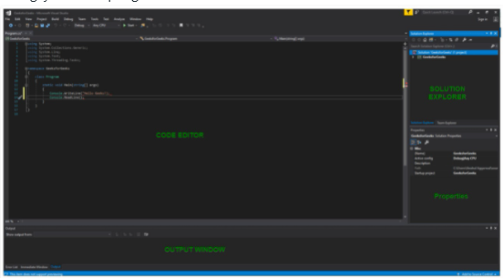

Fig.3.2.1 Diagram showing parts of the Visual studio editor.

**HTML**

[HTML](https://www.educba.com/what-is-html/) is a tag-based language used to development of web pages; [HTML stands](https://www.educba.com/html-stands-for/) for Hyper Text Mark-up Language. Hypertext refers to the way in which Web pages are linked together. Thus, the link available on a webpage is called Hypertext. It is a mark-up language; its tags tell the browser how the page will be rendered on it.

HTML is a language for specifying how text and graphics appear on a web page When you visit a web site (e.g., www.google.com) your web browser retrieves the HTML web page and renders it, the HTML page is actually stored on the computer that is hosting the web site and the page is sent to your browser. HTML is a textual language that includes special mark-up tags such as: The tag specifies a title for the web page HTML code is stored in a simple text file that has either a .htm or a .html filename extension (e.g., restaurant.html).

**CSS**

CSS (CASCADING STYLE SHEETS) is a stylesheet language that describes the presentation of an HTML (or XML) document. CSS describes how HTML elements are to be displayed on screen, paper, or in other media, it saves a lot of work. It can control the layout of multiple web pages all at once. External stylesheets are stored in CSS files. CSS is used to define styles for your web pages, including the design, layout and variations in display for different devices and screen sizes.

A CSS rule-set consists of a selector and a declaration block: The selector points to the HTML element you want to style. The declaration block contains one or more declarations separated by semicolons. Each declaration includes a CSS property name (color and font-size in this example) and a value separated by a colon. A CSS declaration always ends with a semicolon, and declaration blocks are surrounded by curly braces

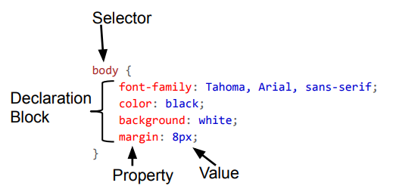

Fig.3.2.2 Parts of CSS

**JavaScript**

JavaScript is a dynamic computer programming language. It is lightweight and most commonly used as a part of web pages, whose implementations allow client-side script to interact with the user and make dynamic pages. It is an interpreted programming language with object-oriented capabilities.

**3.3 The systems use case block diagram and flowchart**

If found books an event, where they provide their email address. Else,

User visits website. Has access to view gallery, and events covered

Scans the site for desired package.

Contacts the website management to schedule desired event.

Fig.3.3.1Block diagram showing how the system works

**Use case diagram for booking**

Searches event lists

Books event

User / Customer

Fig.3.3.2 Use case diagram for booking.

**System use case diagram**

Goes to the website.

Searches for event.

Book event

manager

**Contact to confirm booking**

**Assigning staff to user.**

User

Contacting necessary vendors and persons.

Payment

Keeping up with status of event

Staff(planner)

Fig.3.3.3 Use Case diagram

**User visits site:**

An interested user comes to the website’s home page where they can view the types of services rendered by the event management agency. They can search for the type of event they want, read about the agency and also get an idea of what the agency is capable of doing from the previous event photos found in the website gallery section. If they want to find what they want they can explore the services the agency provides, the prices and former clients or customer’s reviews.

**Searches for desired event:**

This search is done by going to the services page and price page where it is possible to book from, in the services page some of the services can be booked as stand-alone services while the price page gives a breakdown of all services provided at a designated price.

**Booking events:**

When the “Book now” button is clicked it takes the user to the booking page where they are prompted to provide their contact information, date and time of event, and the available budget and type of event (e.g. birthday party).

**Confirmation of booked event:**

Using the provided email address, the user is contacted to verify if the booking is legitimate and find out details of the event like the type of food, music etc. to be provided at the event.

**Assigning of staff:**

Once the booking is confirmed, the manager assigns a planner to the booked event and user, this planner communicates to the customer what goes on with the planning of the event.

**Payment:**

After calculating the necessary factors and involved facilities such as venue booking, transportation, catering, entertainment etc., the planner communicates to the user the budget needed for the event and if the user is agrees the agency’s account is communicated to the user who pays using the transfer payment method which is safer and prevents complications.

**Contacting vendors and necessary persons:**

After payments have been made the planner gets in touch with people that will help the event come to live like caterers, DJs, ushers, photographers, transporters, decorators etc. Doing this ensures that everyone knows that an event is upcoming and make necessary preparations in relations to their part in the event.

**Keeping up the status of the event planning:**

The planner and the user constantly communicate so that the user is updated about what is going on in the event planning.

**System flowchart**

User visits website and scans for preferred event

Finds preference and contacts / books event

Admin contacts user to confirm booking

(Cancels Booking)

(Confirms Booking)

Assigns staff to user for event planning

Payments are made

User keeps up with staff on planning levels

Fig.3.3.4 System flowchart

**WEBSITES USER INTERFACES**

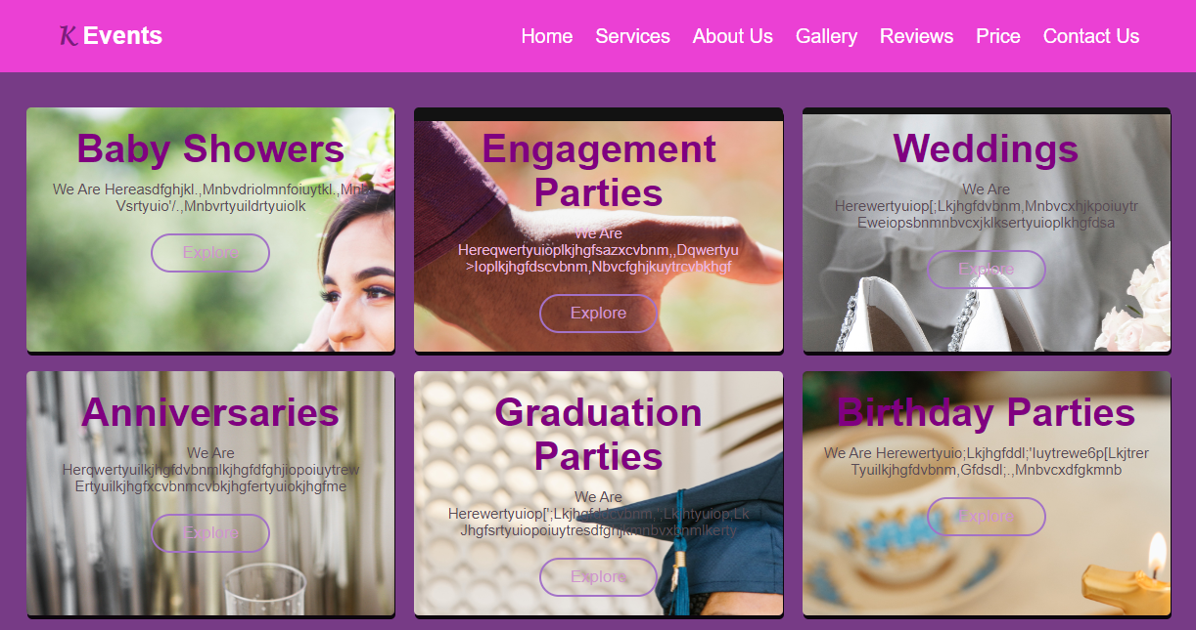

Fig.3.3.5 Home page

The website home page: This shows the visitor what type of events the agency covers. The home pages also house the About us and Gallery section and also the Contact us section shown below.

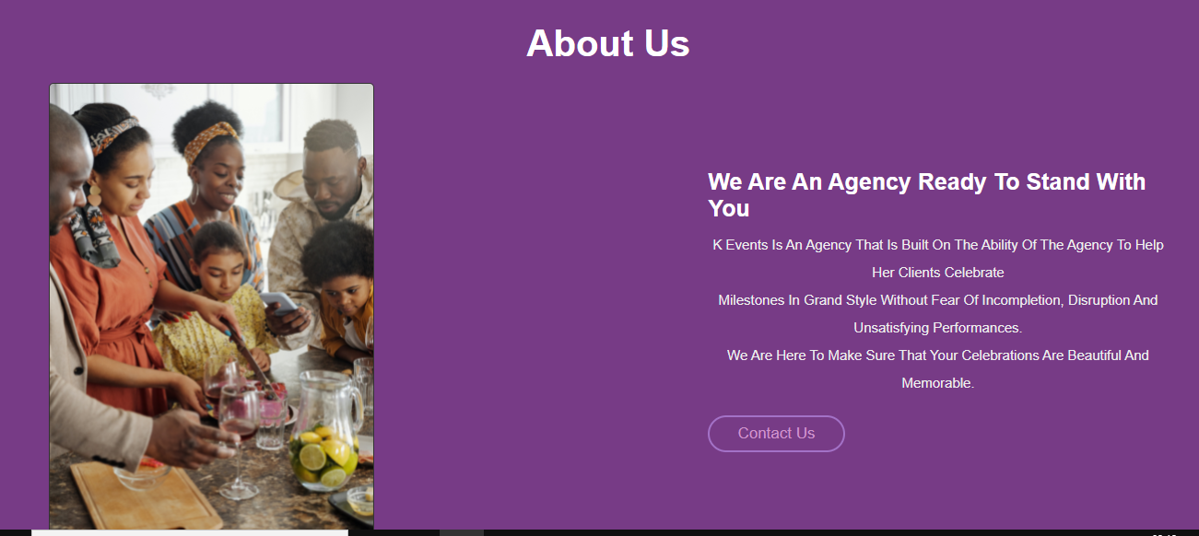

Fig.3.3.6 About us section

The about section helps the visitor learn about the intention of the agency.

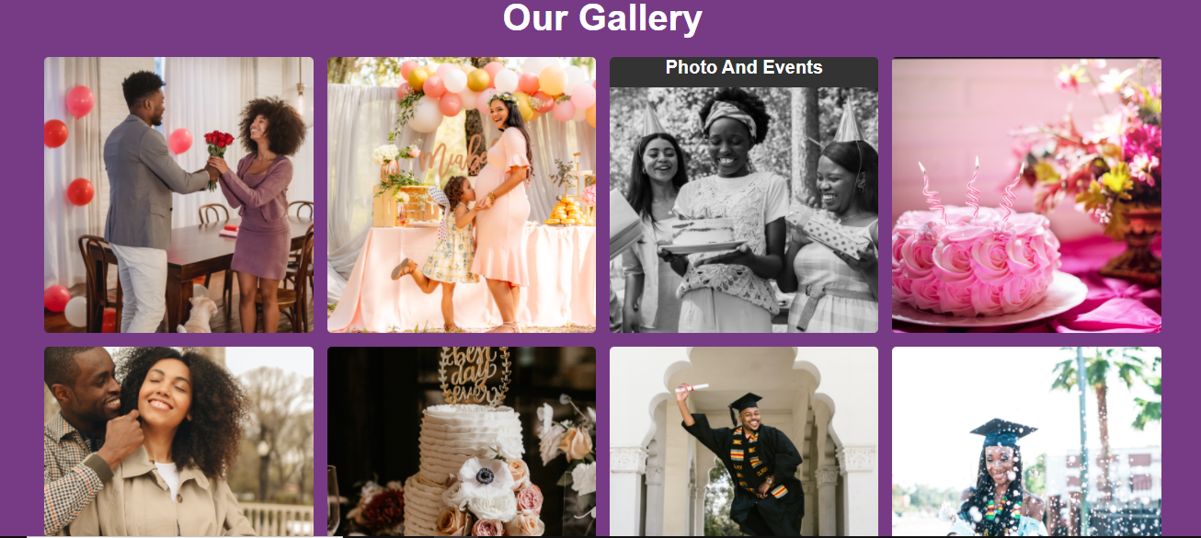

Fig.3.3.7 Gallery section

The gallery gives the visitor a brief view of the agency’s success at their previous events and encourages them to work with the agency.

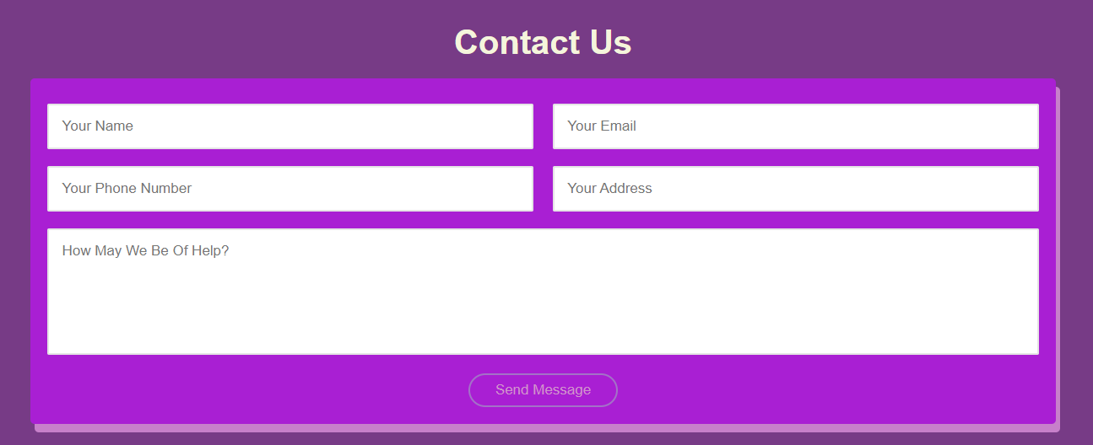

Fig.3.3.8 Contact us section

The contact us section is basically for the user to communicate with the agency what they want that they think is not provided, like if they want a single service from the agency e.g. making of invitation cards only.

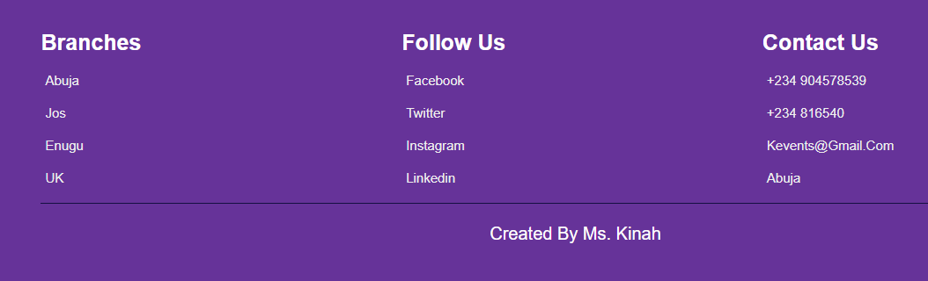

Fig.3.3.9 Footer section

The website’s footer holds information on how else to contact the agency, where their branches are located,and their social media accounts.

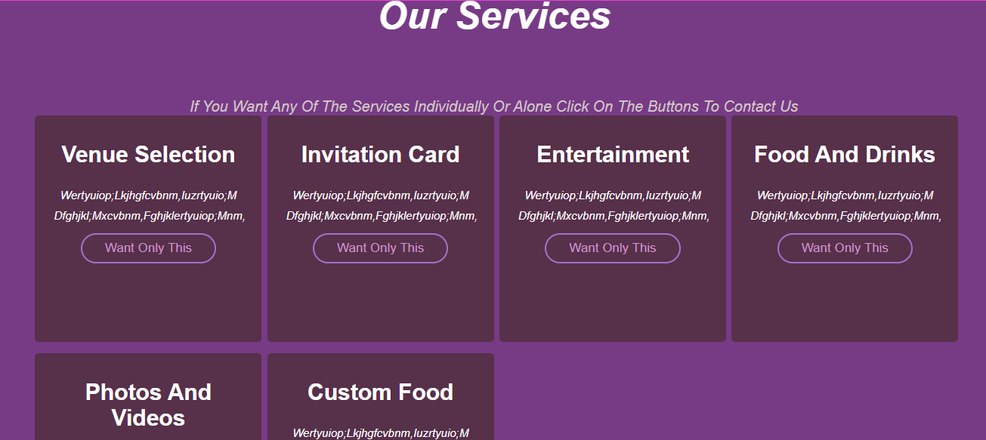

Fig.3.3.10 Service Page

The website’s services page holds the different things the angency does to make an event successful, and if a user wants only one service, they can click on the button that takes them to the contact us section.

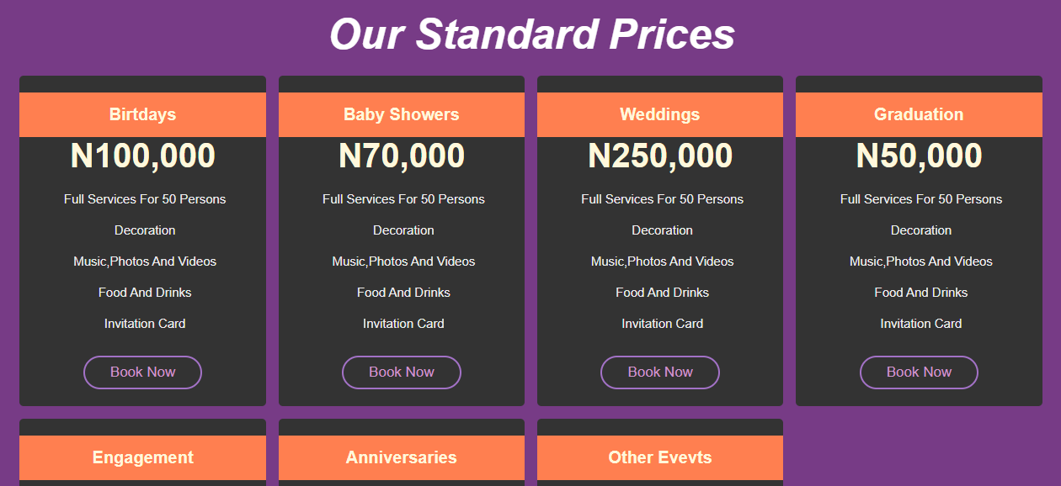

Fig.3.3.11 Price Page

The website’s prices page shows the standard prices for different events they handle and an interested visitor or user can go to the booking page from there.

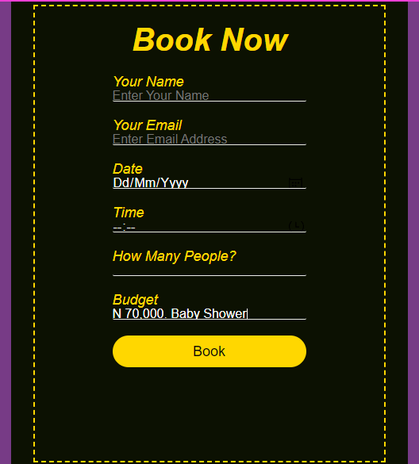

Fig.3.3.12 Booking Page

The booking page sends the booking to the agency’s account where they can contact the user from to confirm booking.

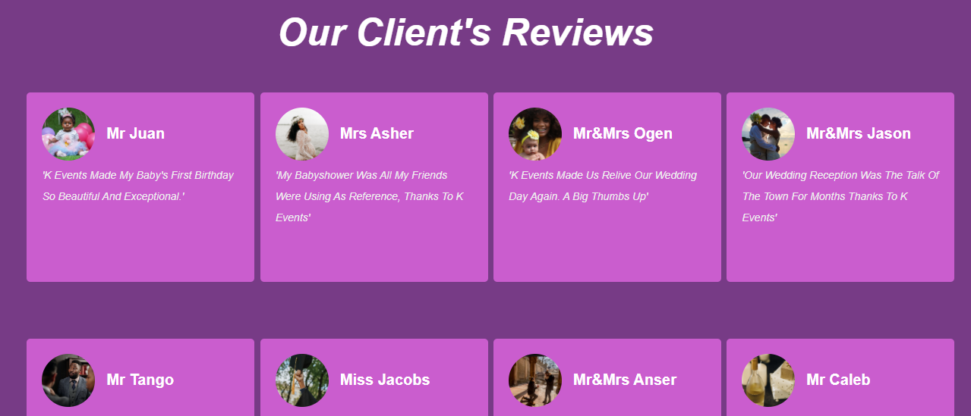

Fig.3.3.13 Client Review Page

The reviews page is made up of the former clients feedback on the work of the agency and how they felt about it.

**3.4 Challenges and Constraints**

The constraints are

* User will get any instant message through e-mail address and not on mobile numbers.
* To get important notification through E-mail, user must have to provide and email address.
* For online payment, the user must confirm booking as refunds will be impossible.
* Online meetings with event organizer/manager are not available.
* Online photos will available of event venues but to analyse the event venue a customer must have to walk up physically at the area where event is going to held.

The challenges are:

* Initially some of the system’s codes were not working
* Finding the agency willing to be part of the project was not an easy fit.
* Finding a way of sending the forms and messages was hectic and annoying since a database was not being used.
* Hosting the website was a hassle.

Solutions to the challenges:

* I had to go back and revise the codes again and find the very little mistakes like semicolons, case sensitive parts and spacings.
* For the form submission and messages challenge a site that helps in tackling such issues called Formspree was used. They basically connect your website forms to an indicated email account.
* The hosting was being done on the wrong site as one can not host a static website on a dynamic hosting site.

**CHAPTER FOUR**

**4.1 Implementation, Testing, and Result**

Implementation involve the steps or methods used to get a system to the point where it is functionally alright, this can be achieved by carrying out procedural tests which are two types unit and integration testing.

**Unit Testing**

Unit testing is a software testing method by which individual units of source code, sets of one or more computer program modules together with associated control data, usage procedures, and operating procedures, are tested to determine whether they are fit for use. Intuitively, one can view a unit as the smallest testable part of an application. The unit test done on this project gave the expected result.

**Integration Testing**

Integration testing (sometimes called integration and testing, abbreviated I&T) is the phase in software testing in which individual software modules are combined and tested as a group. It occurs after unit testing and before validation testing. Integration testing takes as its input modules that have been unit tested, groups them in larger aggregates, applies tests defined in an integration test plan to those aggregates, and delivers as its output the integrated system ready for system testing. The integration test done on the project was successful.

**4.2. BEME**

|  |  |  |  |
| --- | --- | --- | --- |
| **Items** | **Quantity** | **Price of items**  **(per 1)** | **Price of amount used** |
| Laptop containing 6GB RAM and 297GB hard disk. | 1 | N228,500 | N228,500 |
| Visual studio software. | 1 | N3,000(for data subscription for software download) | N3,000 |
| Operating system (Microsoft Windows 10 up | 1 | N5,000 | N5,000 |
| Flash drive | 1 | N2,500 | N2,500 |
| Internet subscription |  | N10,000 | N10,000 |
| Miscellaneous |  | N10,000 | N10,000 |
| Total = N258,500 | | | |

***Table 5. 1 Bill of Engineering Measurement and Evaluation***

**CHAPTER FIVE**

**Summary**

As it was in earlier times, planning for an upcoming event was purely manual. Those organizing events were tasked to walk shop to shop to purchase items and services and monitor them manually before the day of the event. This manual way of planning resulted to most planners going out of budget since much of the resources was channelled to moving around looking for items and services, not in purchasing them. This old-fashioned way is also very tedious because of the long distances’ planners need to cover when going to check on items. These are specific functionalities which the system tends to automate, so this project set out to design and develop an online event management system that would help in carrying out online event scheduling / booking.

**Conclusion**

The event management system of the past required a lot of hassle for the host and also the planner as communication and movement from one place to the other was exhausting, locating a venue could be confusing, and when it evolved there were many agencies and companies that were ready to assist their customers leading to competitions. To make it easier and time efficient for the customers this project was undertaken to create a system thatsaves the user a lot of valuable time, creates employment opportunity for vendors, usher, decorator more easily and saves money while making it possible for planners to know what users want through communication. The project can be used to store or keep all records and the information about events in one place and retrieved in one click, while enabling users to stay on top of the planning from the comfort of their homes.

**Recommendation**

It is recommeended that event managers and planners adopt this online event management system for productivity and efficiency.

**References**

Vaishali P. (2017). Event management system, India,54

Carter, Laurence. (2013) Event Planning. 1st ed, Bloomington, Author House, Print.

Noman, A. Yousaf, M T (2017). Event Management System, Lahore Pakistan,52

Bowdin, G., Johnny A., William O., Rob H., McDonnell I. (2010) Event Management: Principles and Methods, ISBN,90

Nuwagaba, A. (2018). Online event management system a case study: fruitions event planners Kampala,57

Sheren, K. (2015). Difference between static and dynamic websites, USA,2

Mendel Rosenblum (2016). Cascading Style Sheets (CSS), USA,20

Tutorialpoint.com(2018). JavaScript, UK,50

Spiros Mancoridis(2017). Introduction to the Hyper Text markup language (HTML), Greece,23

https://www.scribd.com/document/342098952/Synopsis-of-Event-Management-System https://solutiondots.com/blog/event-management-system-comprehensive-solution-events-management.html 3

[http://www.academia.edu/4593395/Project_Report_On_Event_manag ement](http://www.academia.edu/4593395/Project_Report_On_Event_manag%20ement)

**Appendix A: Source Codes**

**Home page**

<!DOCTYPE html>

<html lang="eng">

 <head>

     <meta charset="UTF-8">

     <meta name="viewport" content="width=device-width,initial-scale=1.0">

     <title>K Events website</title>

     <link rel="stylesheet" href="http://cdnjs.cloudflare.com/ajax/libs/font-awesome/5.15.4/css/all.mins.css">

     <link rel="stylesheet" href="K Events.css">

     <script src="https://kit.fontawesome.com/df5da7ba00.js" crossorigin="anonymous"></script>

 </head>

 <body>

    <header>

        <a href="#" class="logo"><span>K</span> Events</a>

        <div id="menu-bar" class="fas fa-bars"></div>

           <nav class="navbar">

            <a href="K Events.html">Home</a></li>

            <a href="service.html" target="_blank">Services</a></li>

            <a href="#about">About Us</a></li>

            <a href="#gallery">Gallery</a></li>

            <a href="reviews.html" target="_blank">Reviews</a>

            <a href="price.html" target="_blank">Price</a>

            <a href="#contact">Contact Us</a>

       </header>

       <section class="home" id="home">

           <div class="content">

               <span>K Event Planning Agency</span>

               <h3>Creating the most Beautiful and Lasting Memories.</h3>

               <a href="service.html" class="btn">Explore</a>

               <a href="book.html" class="btn">Book Now</a>

           </div>

       </section>

       <section class="step-container">

           <div class="step">

               <h3>Baby showers</h3>

               <p>we are hereasdfghjkl.,mnbvdriolmnfoiuytkl.,mnb<br>vsrtyuio'/.,mnbvrtyuildrtyuiolk</p>

               <a href="service.html" class="btn">Explore</a>

           </div>

           <div class="step1">

            <h3>Engagement Parties</h3>

            <p>we are hereqwertyuioplkjhgfsazxcvbnm,,dqwertyu<br>>ioplkjhgfdscvbnm,nbvcfghjkuytrcvbkhgf</p>

            <a href="service.html" class="btn">Explore</a>

        </div>

        <div class="step2">

            <h3>Weddings</h3>

            <p>we are herewertyuiop[;lkjhgfdvbnm,mnbvcxhjkpoiuytr<br>eweiopsbnmnbvcxjklksertyuioplkhgfdsa</p>

            <a href="service.html" class="btn">Explore</a>

        </div>

      <section class="about" id="about">

          <h1 class="heading">About Us</h1>

          <div class="row">

              <div class="image">

                  <img src="images/babyshower5.png" alt="">

              </div>

              <div class="content">

                  <h3>we are an agency ready to stand with you</h3>

                  <p>K Events is an agency that is built on the ability of the agency to help her clients celebrate<br>milestones in grand style without fear of incompletion, disruption and unsatisfying performances.<br>We are here to make sure that your celebrations are beautiful and memorable.</p>

                  <a href="#contact" class="btn">Contact Us</a>

              </div>

          </div>

      </section>

      <section class="gallery" id="gallery">

          <h1 class="heading">Our Gallery</h1>

          <div class="box-container">

              <div class="box">

                  <img src="images/anniversary12.png" alt="">

                  <h3 class="title">Anniversary</h3>

                  <div class="icons">

                      <a href="#" class="fas fa-heart"></a>

                      <a href="#" class="fas fa-share"></a>

                      <a href="#" class="fas fa-eye"></a>

                  </div>

              </div><div class="box">

                <img src="images/babyshower10.png" alt="">

                <h3 class="title">Photo and events</h3>

                <div class="icons">

                    <a href="#" class="fas fa-heart"></a>

                    <a href="#" class="fas fa-share"></a>

                    <a href="#" class="fas fa-eye"></a>

                </div>

            </div>

       <section class="contact" id="contact">

           <div class="heading">

               <h1>Contact Us</h1>

           </div>

           <form action="https://formspree.io/f/mayazwnq" method="POST" id="my-form">

               <div class="inputBox">

                <input type="text" name="Name" placeholder="Your name" required>

                <input type="email" name="Email" placeholder="Your email" required>

               </div>

               <div class="inputBox">

                <input type="text" name="Pphone number" placeholder="Your Phone number" required>

                <input type="text" name="Address" placeholder="Your address" required>

               </div>

               <textarea placeholder="How may we be of help?" name="message" id="message" cols="30" rows="10"></textarea>

               <input type="submit" value="Send message" class="btn">

               <p id="my-form-status"></p>

           </form>

       </section>

       <section class="footer">

           <div class="box-container">

               <div class="box">

                   <h3>Branches</h3>

                   <a href="#"><i class="fas fa-map-marker-alt"></i>Abuja</a>

                   <a href="#"><i class="fas fa-map-marker-alt"></i>Jos</a>

                   <a href="#"><i class="fas fa-map-marker-alt"></i>Enugu</a>

                   <a href="#"><i class="fas fa-map-marker-alt"></i>UK</a>

               </div>

               <div class="box">

                <h3>Follow Us</h3>

                <a href="#"><i class="fab fa-facebook-f"></i>Facebook</a>

                <a href="#"><i class="fab fa-twitter"></i>Twitter</a>

                <a href="#"><i class="fab fa-instagram"></i>Instagram</a>

                <a href="#"><i class="fab fa-linkedin"></i>Linkedin</a>

            </div>

            <div class="box">

                <h3>Contact Us</h3>

                <a href="#"><i class="fas fa-phone"></i>+234 904578539</a>

                <a href="#"><i class="fab fa-whatsapp"></i>+234 816540</a>

                <a href="#"><i class="fas fa-envelope"></i>kevents@gmail.com</a>

                <a href="#"><i class="fas fa-map-marker-alt"></i>Abuja</a>

            </div>

           </div>

           <div class="credit">Created by Ms. Kinah</div>

       </section>

**Services page**

 <section class="services" id="services">

        <h1 class="heading">Our Services</h1>

        <p>If you want any of the Services individually or alone click on the buttons to Contact us</p>

        <div class="box-container">

            <div class="box">

                <i class="fas fa-map-marker-alt"></i>

                <h3>Venue selection</h3>

                <p>wertyuiop;lkjhgfcvbnm,iuzrtyuio;m<br>dfghjkl;mxcvbnm,fghjklertyuiop;mnm,</p>

                <a href="K Events.html#contact" class="btn">Want only this</a>

            </div>

            <div class="box">

             <i class="fas fa-envelope"></i>

             <h3>Invitation card</h3>

             <p>wertyuiop;lkjhgfcvbnm,iuzrtyuio;m<br>dfghjkl;mxcvbnm,fghjklertyuiop;mnm,</p>

             <a href="K Events.html#contact" class="btn">Want only this</a>

         </div>

         <div class="box">

             <i class="fas fa-music"></i>

             <h3>Entertainment</h3>

             <p>wertyuiop;lkjhgfcvbnm,iuzrtyuio;m<br>dfghjkl;mxcvbnm,fghjklertyuiop;mnm,</p>

             <a href="K Events.html#contact" class="btn">Want only this</a>

         </div>

         <div class="box">

             <i class="fas fa-utensils"></i>

             <h3>Food and Drinks</h3>

             <p>wertyuiop;lkjhgfcvbnm,iuzrtyuio;m<br>dfghjkl;mxcvbnm,fghjklertyuiop;mnm,</p>

             <a href="K Events.html#contact" class="btn">Want only this</a>

         </div>

         <div class="box">

             <i class="fas fa-photo-video"></i>

             <h3>Photos and Videos</h3>

             <p>wertyuiop;lkjhgfcvbnm,iuzrtyuio;m<br>dfghjkl;mxcvbnm,fghjklertyuiop;mnm,</p>

             <a href="K Events.html#contact" class="btn">Want only this</a>

         </div>

         <div class="box">

             <i class="fas fa-birthday-cake"></i>

             <h3>Custom food</h3>

             <p>wertyuiop;lkjhgfcvbnm,iuzrtyuio;m<br>dfghjkl;mxcvbnm,fghjklertyuiop;mnm,</p>

             <a href="K Events.html#contact" class="btn">Want only this</a>

         </div>

        </div>

    </section>  
  
**Price page**

 <section class="price" id="price">

    <h1 class="heading">Our Standard Prices</h1>

    <div class="box-container">

        <div class="box">

            <h3 class="title">Birtdays</h3>

            <h3 class="amount">N100,000</h3>

            <ul>

                <li><i class="fas fa-check"></i>Full Services for 50 Persons</li>

                <li><i class="fas fa-check"></i>Decoration</li>

                <li><i class="fas fa-check"></i>Music,Photos and Videos</li>

                <li><i class="fas fa-check"></i>Food and Drinks</li>

                <li><i class="fas fa-check"></i>Invitation card</li>

            </ul>

            <a href="book.html" class="btn">Book Now</a>

        </div>

        <div class="box">

          <h3 class="title">Baby Showers</h3>

          <h3 class="amount">N70,000</h3>

          <ul>

            <li><i class="fas fa-check"></i>Full Services for 50 Persons</li>

              <li><i class="fas fa-check"></i>Decoration</li>

              <li><i class="fas fa-check"></i>Music,Photos and Videos</li>

              <li><i class="fas fa-check"></i>Food and Drinks</li>

              <li><i class="fas fa-check"></i>Invitation card</li>

          </ul>

          <a href="book.html" class="btn">Book Now</a>

      </div>

       <script>

           let menu = document.querySelector('#menu-bar');

           let navbar = document.querySelector('.navbar');

           menu.addEventListener('click',() =>{

               menu.classList.toggle('fa-times');

               navbar.classList.toggle('nav-toggle');

           });

           window.onscroll = () =>{

            menu.classList.remove('fa-times');

               navbar.classList.remove('nav-toggle');

           }

        </script>

       <script src="js/script.js"></script>

</body>

<script>

    var form = document.getElementById("my-form");

    async function handleSubmit(event) {

      event.preventDefault();

      var status = document.getElementById("my-form-status");

      var data = new FormData(event.target);

      fetch(event.target.action, {

        method: form.method,

        body: data,

        headers: {

            'Accept': 'application/json'

        }

      }).then(response => {

        status.innerHTML = "Thanks for contacting us! Your message has been received";

        form.reset()

      }).catch(error => {

        status.innerHTML = "Sorry! There was a problem sending your message"

      });

    }

    form.addEventListener("submit", handleSubmit)

</script>

</html>

**Booking page**

<div class="book-container">

        <div class="container-form">

            <form action="https://formspree.io/f/xeqvwjol" method="POST" id="my-form">

                <h2 class="heading" heading-yellow>Book Now</h2>

                <div class="form-field">

                    <p>Your Name</p>

                    <input type="text" name="Booking name" placeholder="Enter your name" required>

                    <p>Your Email</p>

                    <input type="email" name="Booking email" placeholder="Enter Email address" required>

                    <p>Date</p>

                    <input type="date" name="Booking date">

                    <p>Time</p>

                    <input type="time" name="Booking time">

                    <p>How many people?</p>

                    <input type="number" name="Booking persons">

                    <p>Budget</p>

                    <input type="text" name="Budget" placeholder="Enter your type of event too">

                </div>

             <input type="submit" name=""  onclick="popUp()"   value="Book">

             <p id="my-form-status"></p>

            </form>

        </div>

    </div>

<script>

    var form = document.getElementById("my-form");

    async function handleSubmit(event) {

      event.preventDefault();

      var status = document.getElementById("my-form-status");

      var data = new FormData(event.target);

      fetch(event.target.action, {

        method: form.method,

        body: data,

        headers: {

            'Accept': 'application/json'

        }

      }).then(response => {

        status.innerHTML = "Thanks for choosing us! Booking successful";

        form.reset()

      }).catch(error => {

        status.innerHTML = "Sorry! There was a problem booking your event"

      });

    }

    form.addEventListener("submit", handleSubmit)

</script>

**Review page**

<section class="reviews" id="reviews">

        <h1 class="heading">Our Client's reviews</h1>

        <div class="box-container">

                <div class="box">

                    <div class="user">

                        <img src="images/birthday16.png" alt="">

                        <div class="user-info">

                            <h3>Mr Juan</h3>

                        </div>

                    </div>

                    <p>'K Events made my baby's first birthday so beautiful and exceptional.'</p>

                </div>

                <div class="box">

                    <div class="user">

                        <img src="images/babyshower3.png" alt="">

                        <div class="user-info">

                            <h3>Mrs Asher</h3>

                        </div>

                    </div>

                    <p>'My babyshower was all my friends were using as reference, thanks to K Events'</p>

                </div>

                </div>

**Styling page**

@import url('http://fonts.googleapis.com/css2?family=Roboto:ital,wght@0,100;0,300;0,400;0,500;0,700;1,100;1,300&display=swap');

:root{

    --pink: rgb(224, 88, 133);

    --black:#773b86;

}

*{

    font-family: 'Roboto',sans-serif;

    margin: 0;

    padding: 0;

    box-sizing: border-box;

    text-decoration: none;

    outline: none;

    border: none;

    transition: .2s linear;

    text-transform: capitalize;

}

*::selection{

    background:plum;

    color: #fff;

}

html{

    font-size: 62.5%;

    overflow-x: hidden;

    scroll-padding-top: 6.5rem;

    scroll-behavior: smooth;

}

body{

    background-color: var(--black);

}

section{

    padding: 3rem 5%;

}

.heading{

    text-align: center;

    padding-bottom: 2rem;

    color: #fff;

    text-transform: capitalize;

    font-size: 4rem;

}

.contact .heading h1{

    text-align: center;

    text-decoration: beige;

    font-size: 4rem;

    color: beige;

}

.btn{

    display: inline-block;

    margin-top: 1rem;

    border: .2rem solid rgb(163, 114, 199);

    color: rgb(207, 149, 204);

    font-size: 1.7rem;

    padding: .8rem 3rem;

    cursor: pointer;

    background: none;

    border-radius: 2rem;

}

.btn:hover{

    background: var(--pink);

    border-color: var(--pink);

    color: #fff;

}

header{

    position: fixed;

    top: 0;

    left: 0;

    right: 0;

    z-index: 10000;

    background: rgb(235, 64, 212);

    padding: 2rem 9%;

    display: flex;

    align-items: center;

    justify-content: space-between;

}

header .logo{

    font-size: 2.5rem;

    color: #fff;

    font-weight: bolder;

}

span{

    color:rgb(126, 27, 126);

    font-family: Lucida Handwriting;

}

header .navbar a{

    color: #fff;

    font-size: 2rem;

    margin-left: 2rem;

}

header .navbar a:hover{

    color: purple;

}

#menu-bar{

    font-size: 3rem;

    color: #fff;

    border-radius: .5rem;

    border: .1rem solid #fff;

    padding: .5rem 1.5rem;

    cursor: pointer;

    display: none;

}

.home{

    min-height: 100vh;

    display: flex;

    align-items: center;

    background: url(images/kevents6.png) no-repeat;

    background-size: cover;

    background-position: center;

    background-attachment: fixed;

}

.home .content span{

    font-size: 3rem;

    color: rgb(245, 228, 245);

}

.home .content h3{

    font-size: 6rem;

    color: white;

    width: 60rem;

}

.step-container{

    display: flex;

    align-items: center;

    justify-content: center;

    flex-wrap: wrap;

}

.step-container .step{

    background: url(images/babyshower4.png);

    margin: 1rem;

    padding: 2rem;

    border-radius: .5rem;

    height: 250px;

    width: 50%;

    box-shadow: 0.1rem 0.4rem rgba(0, 0,0, .9);

    text-align: center;

    flex:.3 .3 30rem;

    font-size: 2rem;

}

.services .heading{

    font-size: 5rem;

    font-style: italic;

    margin-top: 5%;

}

.services p{

    font-size: 2rem;

    font-style: italic;

    margin-top: 5%;

    text-align: center;

    color: rgb(209, 196, 196);

}

.services .box-container{

    display: grid;

    grid-template-columns: repeat(auto-fit, minmax(27rem, 1fr));

    gap: 1.5rem;

}

.services .box-container .box{

    border-radius: .5rem;

    background: rgb(87, 48, 74);

    text-align: center;

    padding: 2.5rem;

    height: 30rem;

    width: 30rem;

}

.services .box-container .box i{

    height: 6rem;

    width: 6rem;

    line-height: 6rem;

    border-radius: 50%;

    font-size: 2.5rem;

    background-color: rgb(42, 28, 56);

    color: rgb(225, 223, 231);

}

.services .box-container .box h3{

    font-size: 3rem;

    color: #fff;

    padding: 1rem 0;

}

.about .row{

    display: flex;

    align-items: center;

    flex-wrap: wrap;

    gap: 1rem;

}

.about .row .image img{

    width: 50%;

    border-radius: 0.5rem;

    border: .1rem solid #333;

 }

.about .row .content{

    flex: 1 1 45rem;

}

.about .row .content h3{

    text-align: left;

    font-size: 2.5rem;

    color: #fff;

}

.about .row .content p{

    text-align: center;

    font-size: 1.5rem;

    color: #eee;

    padding: 1rem 0;

    line-height: 2;

}

.gallery .box-container{

    display: grid;

    grid-template-columns: repeat(auto-fit, minmax(27rem, 1fr));

    gap: 1.5rem;

}

.gallery .box-container .box{

    position: relative;

    border: 1rem ;

    border-radius: .5rem;

    height: 30rem;

    cursor: pointer;

    overflow: hidden;

}

.gallery .box-container .box img{

    height: 100%;

    width: 100%;

    object-fit: cover;

}

.gallery .box-container .box:hover img{

    transform: scale(1.1);

    filter:grayscale();

}

.gallery .box-container .box .title{

    position: absolute;

    top: -10rem;

    left: 0;

    right: 0;

    background: #333;

    color: #fff;

    text-align: center;

    padding-bottom: 1rem;

    font-size: 2rem;

}

.price .box-container .box ul li{

    font-size: 1.5rem;

    color: #eee;

    padding: 1rem 0;

}

.price .box-container .box ul li i{

    color: indianred;

    padding-right: .5rem;

}

.reviews .heading{

    font-size: 5rem;

    font-style: italic;

    margin-top: 5%;

}

.reviews .box-container {

    display: grid;

    grid-template-columns: repeat(auto-fit, minmax(25rem, 1fr));;

    gap: 1.5rem;

}

.reviews .box-container .box{

    border-radius: .5rem;

    background: rgb(202, 93, 206);

    margin: 3rem;

    padding: 2rem;

    height: 25rem;

    width: 30rem;

}

.reviews  .box-container.box .fa-quote-rigt{

    position: absolute;

    top: 2rem;

    right: 2rem;

    color: #EE0548;

    font-size: 5rem;

}

.reviews .box-container .box .user{

    display: flex;

    align-items: center;

    gap: 1.5rem;

    scroll-padding-bottom: 1rem;

}

.reviews .box-container .box .user img{

    height: 7rem;

    width: 7rem;

    border-radius: 50%;

    object-fit: cover;

}

.reviews .box-container .box .user h3{

    font-size: 2rem;

    color: #fff;

}

@media (max-width:1200px){

    html{

        font-size: 55%;

    }

}

@media (max-width:991px){

    header{

        padding: 2rem 4%;

    }

    section{

        padding: 3rem 3%;

    }

}

@media (max-width:768px){

    #menu-bar{

        display: block;

    }

 }

    .home{

        justify-content: center;

        background-position: left;

    }

    .home .content{

        text-align: center;

    }

    .home .content span{

        font-size: 2rem;

    }

    .home .content h3{

        font-size: 4rem;

        width: auto;

    }

    .contact form .inputBox input{

        width: 100%;

    }